Physical Geology 101 - Name:_____________________________
Dr. Jan Rasmussen jrasmussen@pima.edu http://www.janrasmussen.com

Lab - Valley Glaciers B Alaska
Answer the following questions using the stereo photos, photos, and your lab manual (Hamblin & Howard).

9. Valley Glaciers B Alaska (single photo, top of page)
a. What is the source of the material that makes up a moraine?

b. Are the moraines moving or are they stationary?

c. What is the origin of a medial moraine?

d. At least fourteen medial moraines occur in the main glacier. How many tributary glaciers occur in this system?

e. What evidence in this area indicates that glacial ice flows?

f. Study the ice in the small tributaries. Does it flow faster, slower, or at about the same velocity as the ice in the main stream?

g. What feature on the surface of the glacier indicates areas of major extending flow.

10. Valley Glaciers B Alaska (single photo, bottom of page)
a. What type of drainage pattern occurs in the outwash plain? (hint - check drainage patterns in the River system - chapter 10).

b. Why does this drainage pattern develop?

c. What is the origin of the numerous small lakes in the terminal and recessional moraines?

d. What evidence indicates that at one time the glacier extended beyond the >terminal= moraine?

e. How many recessional moraines can you identify? How do they form?

f. Compare and contrast the nature of sediment in the moraines with those in the outwash plain (hint - look in the text book)

.
g. What evidence indicates that the terminus of a glacier is a zone of compressing flow?

11. Valley Glaciers B Alaska (stereo pair photos, top of page)
a. What evidence indicates that lateral and medial moraines are derived from mass movement on the valley walls?

b. What evidence indicates that the various tributary glaciers flow at different rates?

c. Give possible reasons for the difference in the color and texture of the medial moraines.

d. What evidence shown in these photographs indicates that glacial ice flows?

e. What causes the crevasses in the tributary glaciers where they enter the main glacier?

12. Valley Glaciers B Alaska (stereo pair photos, bottom of page)

a. Several different terminal moraines are distinguishable by differences in form, texture, and growth of vegetation (red color). Explain briefly the glacial history that each of these record.

b. Explain why the end of this glacier is completely covered with moraine sediments.

c. How can you distinguish between older and younger lateral moraines in this area?

d. What is the origin of the small lakes near the bottom of the photographs?
9. Valley glaciers – Alaska
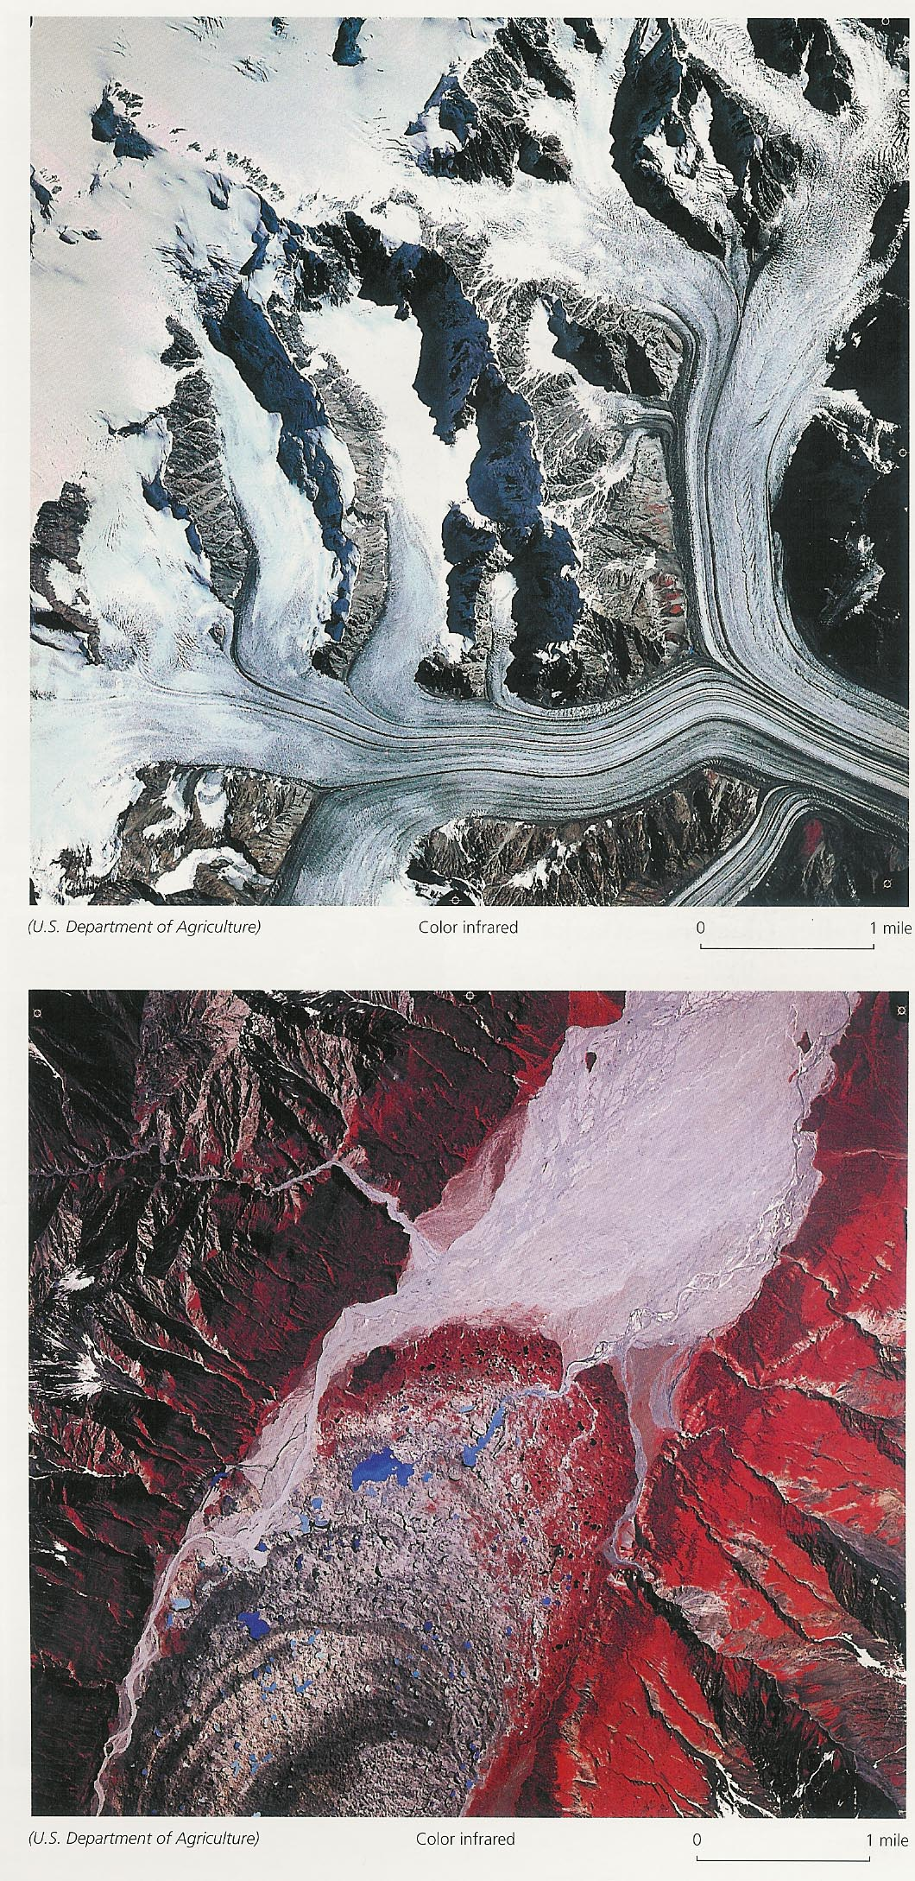
10. Valley glaciers – Alaska

11. Valley glaciers – Alaska 12. Valley Glaciers - Alaska


